**ASSIGNMENT (MODULE-3) HTML**

**NAME:- NIKUNJ SAVALIA MOBILE NO.:-8866610103**

1. **Are the HTML tags and elements the same thing?**

* HTML Tags and Elements are not same thing. Both are different.
* Elements in use opening and closing tag .
* Elements enclose the contents in between tags. They consist of some kind of structure or expression.

Ex.- <i> Keep Thinking Different <i>

OUT PUT:- *Keep Thinking Different*

* HTML Tag:- Tags are the starting and ending parts of an HTML element. The being with < symbol and end with > symbol. Whatever written inside <p> are called tags.

Ex. <h1> </h1>,<style> </style>

1. **What are tags and attributes in HTML?**

* HTML attributes are special words used inside the opening tag to control the element’s behaviour.
* In html syntax, an attribute is added to a HTML start tag. (they are always included in the opening tag and consist of name and a value.) separated by an equal sign(=).

Ex.-(1) <img src="aaaa.jpg" alt="">

(2) <a href=""><i class="fa-solid fa-house fa-lg" style="color: #f19009;"></i></a>

1. **What are void elements in HTML? With Example**.

* Void elements is a special group of elements that only have start tags and does not contain any content within it, these element are called void elements.

Ex.<br>,<hr>,<img>,<input>,<link>,<meta>,<area>,<keygen> etc.

<body>

    <a href="">Home</a>

    <input type="text" name="" id="">

</body>

OUT SOURCE:- 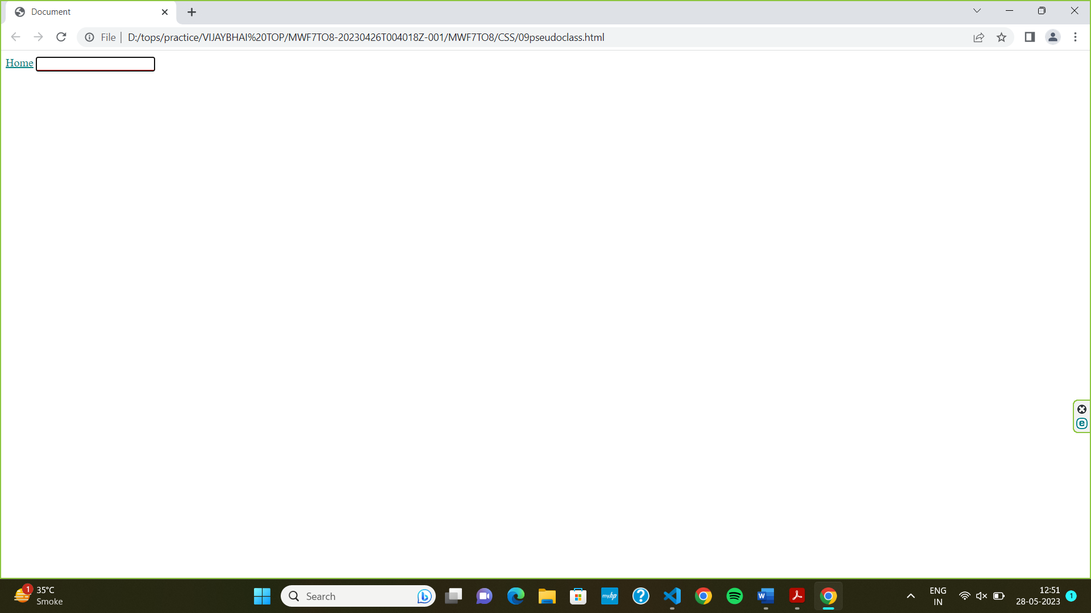

1. **What are HTML Entities? With Example.**

* Entities are special characters or symbols that cannot be entered directly from the keyboard , but instead need to be represented by a code. Entities are used to display characters such as arrows, mathematical symbol and non-Latin characters and specified using the “&” symbol followed by a name or number.

Ex. > for greater than symbol (>)

< for less than symbol (<)

& for ampersand (&)

© for copyright symbol (©)

1. **What are different types of lists in HTML? With Example.**

* <ul> Defines an uncorded list

<html>

<body>

    <div>

        <ul>

            <li>cricket 07</li>

            <li>cricket 09</li>

            <li>cricket 19</li>

            <li>cricket 22</li>

        </ul>

    </div>

</body>

</html>

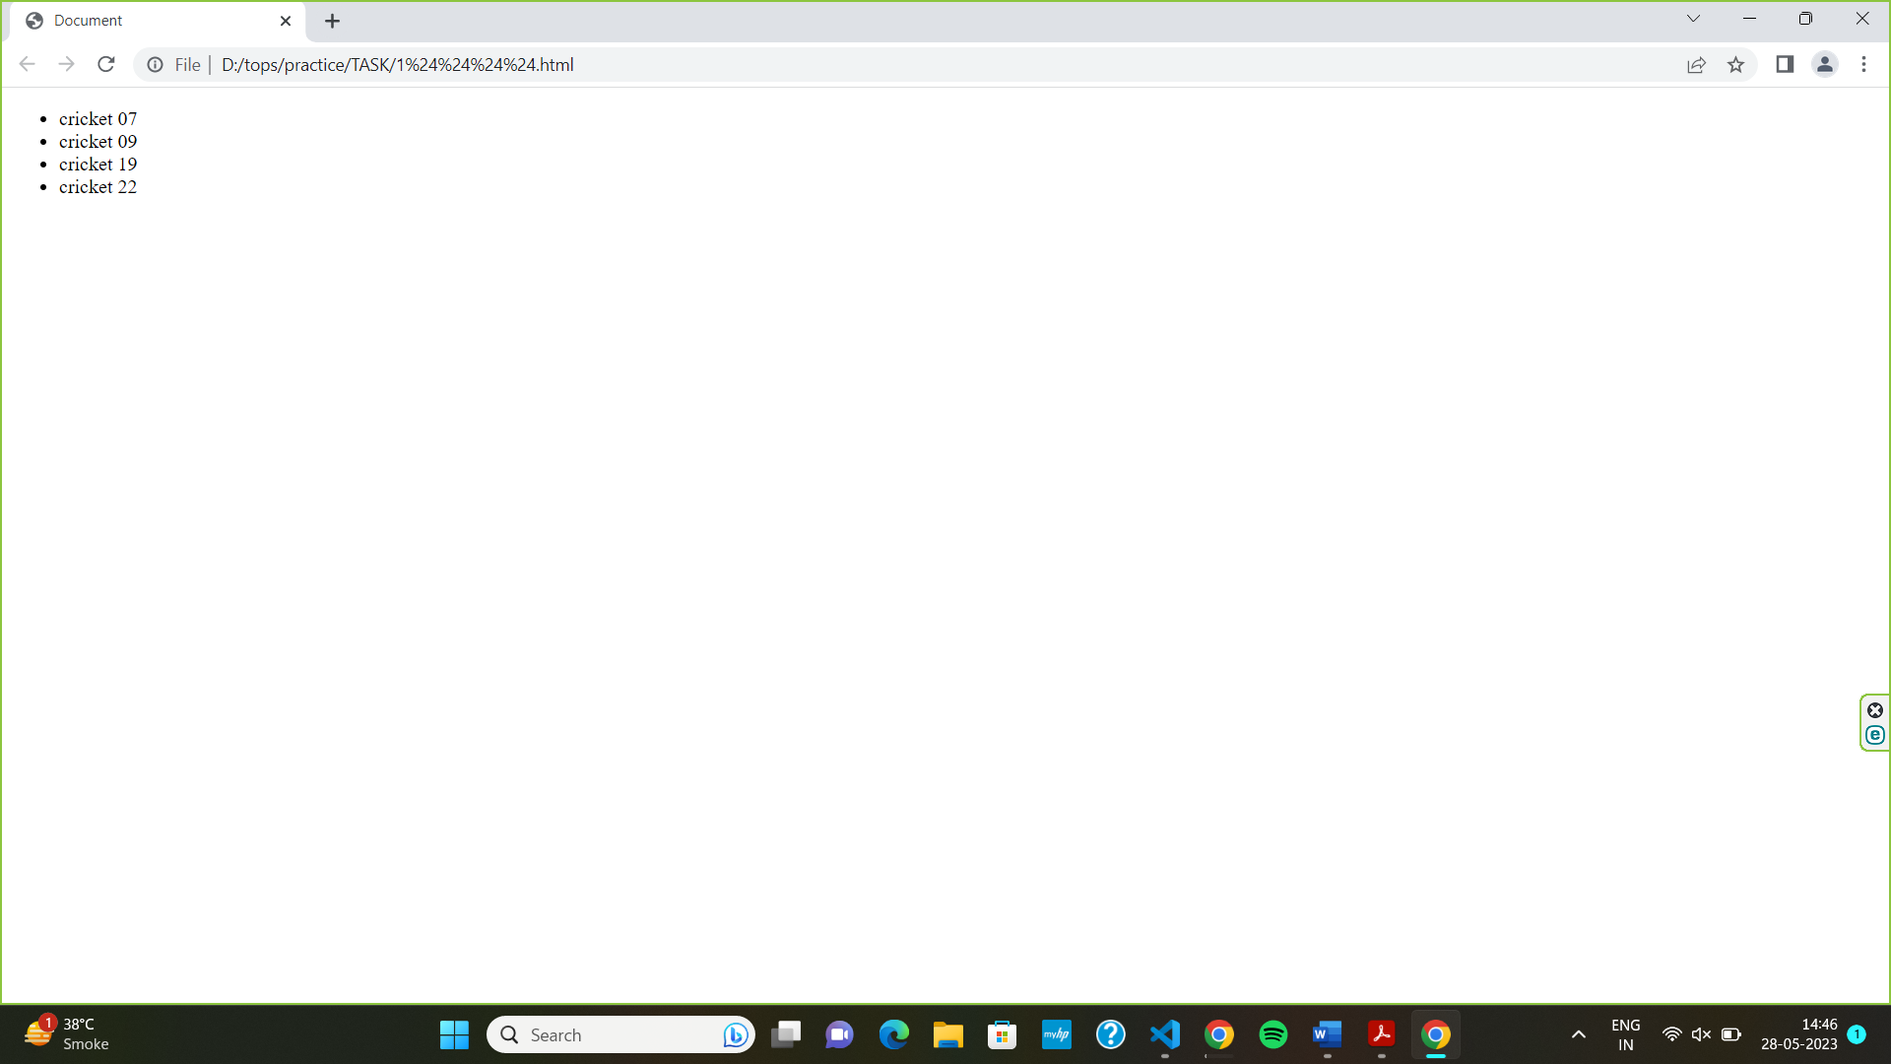

* <ol> Defines an ordered list
* <body>
* <div>
* <ol>
* <li>html</li>
* <li>css</li>
* <li>c++</li>
* <li>paython</li>
* </ol>
* </div>
* </body>
* </html>

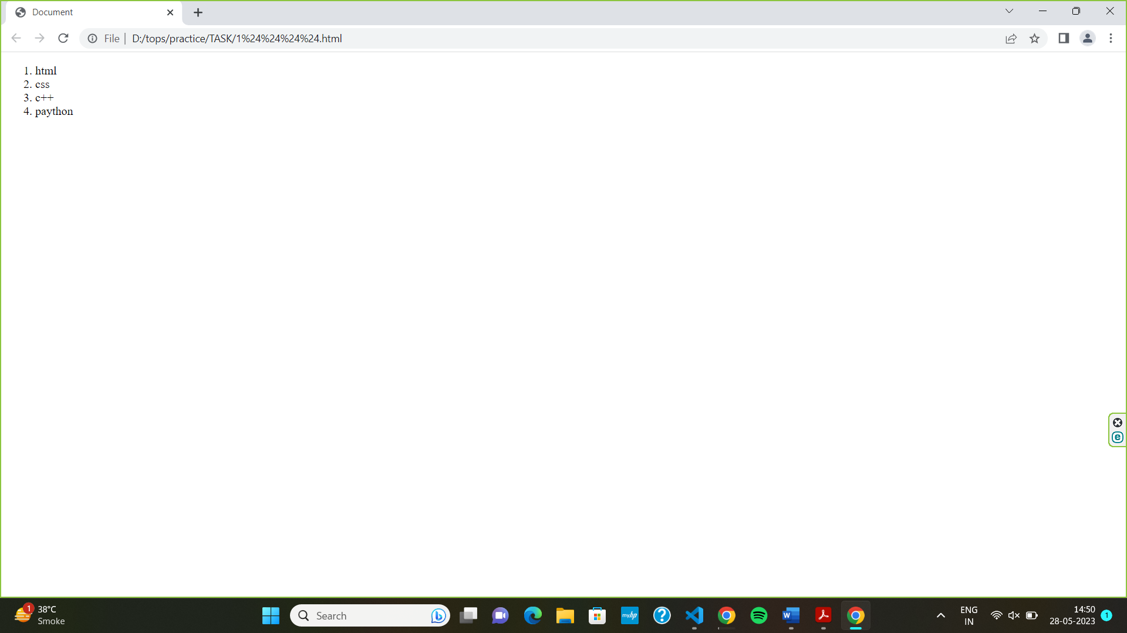

* <li> Defines a list item
* <dl> Defines a description list
* <dt> Defines a term in a description list
* <dd> Describes the term in a description list

1. **What is the ‘class’ attribute in HTML? With Example.**

* Class attribute is specify one or more class name for an element.
* Commonly the class attribute points to a class in a style sheet. The class name is case sensitive.

Ex.- one class name:-

<body>

    <h1 class="color"></h1> this is the first color red</h1>

    <h2 class="color"></h2> this is the second color green</h2>

    <h3 class="color"></h3> this is the thired color blue</h3>

</body>

One and more class name:-

<body>

    <h1 class="1"></h1> this is the first color red</h1>

    <h2 class="2"></h2> this is the second color green</h2>

    <h3 class="3"></h3> this is the thired color blue</h3>

</body>

1. **What is the difference between the ‘id’ attribute and the ‘class’ attribute of HTML elements? With Example.**

* The basic difference between id and class is that the id selector is applied only to one element in a page.
* Whereas the class selector can be applied to several elements on a single page.
* For an HTML element, the “id” name starts with the symbol ‘#’ followed by unique name.
* The class selector start with a period(.) followed by a class name.

**EX.:-**

<style>

        #main-heading {

                        color: darkcyan;

                       }

       .text {

              color: coral;

            }

    </style>

</head>

<body>

    <h1 id="main-heading" class="text heading-text">START SMALL MAKE A BIG </h1>

    <p class="text">NIKUNJ SAVALIA</p>

</body>

</html>

**OUT PUT:-**

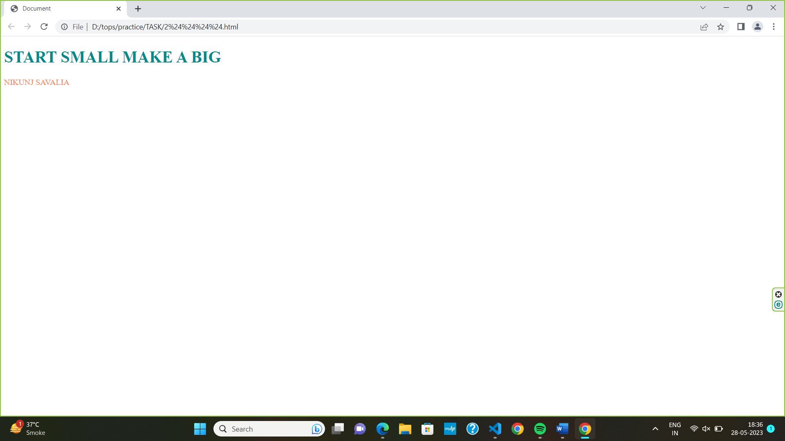

1. **What are the various formatting tags in HTML?**

* Html formatting is a process of formatting text for better look and feel.
* Html provides us ability to format text without using css.
* There are many formatting tags in html.

Ex.:-

**<b>** defines bold text

**<i>** defines italic text

**<mark>** defines marked text

**<big>**  defines text with larger font size

1. **How is Cell Padding different from Cell Spacing? With Example.**

* The cell padding property sets the distance between the edge of a box shaped element’s border and its content. It applies to block -level boxes with borders but not those with none.it concerns just one cell.
* Cell spacing is the space between cells in a table. This can be either vertical or horizontal, depending on your needs. Cell spacing is the space between two cell in a table. It is exposed to several cells (more than one) at once.

EX.:-

<style>

    body {

        height: 100px;

        width: 100px;

    }

table, th, td {

  border: 1px solid black;

}

td{

    padding: 25px 100px 25px 100px;

}

table {

  border-spacing: 30px;

}

</style>

</head>

<body>

<h2>Cellspacing</h2>

<p>cellspading</p>

<table style="width:100%">

  <tr>

    <th>Firstname</th>

    <th>Lastname</th>

    <th>Age</th>

  </tr>

  <tr>

    <td>NIKUNJ</td>

    <td>SAVALIA</td>

    <td>29</td>

  </tr>

</table>

</body>

</html>

**OUT PUT:-**

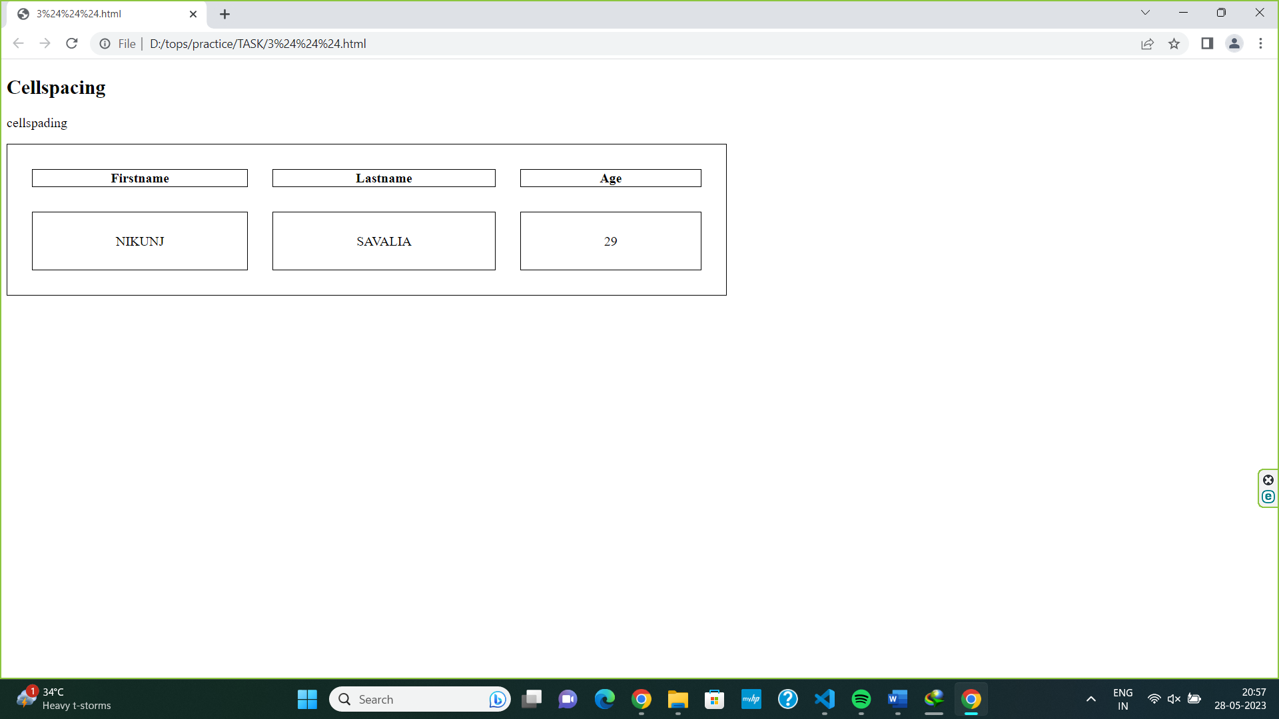

1. **How can we club two or more rows or columns into a single row or column in an HTML table? With Example.**

* We can merge cells in html by using the colspan and rowspan attributes.
* The rowspan attribute is for the number of row that a cell should span, while the colspan attribute is for the number of columns that a should span.
* Rowspan and colspan attributes will be inside <td> tag. Number will be a numeric value. For ex. 2 rows for 2rows if rowspan, 2 columns for 2 columns if colspan

<style>

 table, th, td {

 border: 1px solid black;

 width: 100px;

 height: 50px;

 }

 </style>

 <body>

    <h1>Heading</h1>

    <table>

        <tr>

            <th colspan="3"></th>

         <th></th>

         <th></th>

        </tr>

        <tr>

            <td></td>

            <td></td>

            <td></td>

            <td rowspan="2"></td>

        </tr>

    </table>

 </body>

 </html>

**OUT PUT:-**

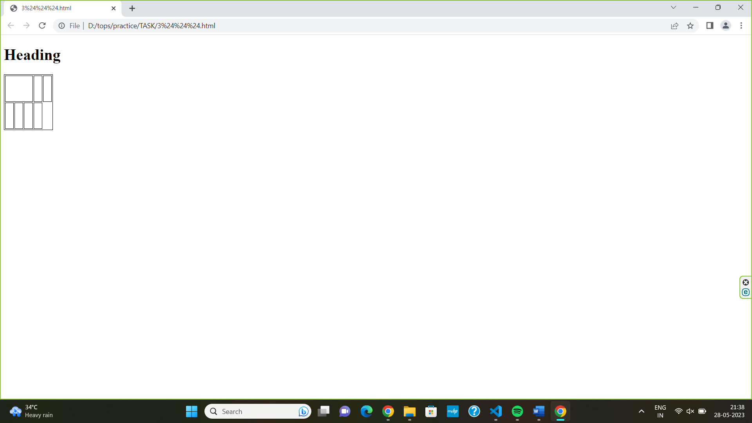

1. **What is the difference between a block-level element and an inline element?**

* Block-level elements take the available full width. Those elements always start with a new line.
* Ex.:-

<p> Nikunj</p>

<h1> savalia</h1>

<h2>……….</h2>

* Inline elements take only the required width. Inline elements do not start with a new line.
* Ex.:-
* <a href=""><i class="fa-solid fa-house fa-lg" style="color: #f19009;"></i></a>

1. **How to create a Hyperlink in HTML? With Example.**

* Hyperlink create use the <a> element to define a link.
* After target using opens the document in a window.

Ex.:-

<a href="https://cdnjs.com/libraries/font-awesome"> visite logo web site</a>

1. **What is the use of an iframe tag? With Example.**

* We know iframe tage is an additional element to share content from other site.
* The <iframe>………</iframe> tage is used to contain the video within the iframe.
* The iframe source (src) is the origin of the content from the external or internal server. Don’t forget to put the embedded code in the URL.
* Width and height is the aspect ratio of the iframe. We can insert a fixed sizes such as 680 x 480 pixels (px) as in the example. We can also use a percentage (10%-100%) based method to adjust the iframe automatically.

Ex.:-

<body>

    <iframe src="https://www.youtube.com/watch?v=Ai2Juxs3jx8&pp=ygUMZGF2aWQgZ3VldHRh" width="680" height="480" allowfullscreen></iframe>

</body>

1. **What is the use of a span tag? Explain with example?**

* The html span element is a generic inline container for inline elements and content.
* It used to group elements for styling purposes (by using the class or id attributes)
* Span tag use change the language of a part of the text.
* To change the colour , font , background of apart of text using css
* To apply the scripts to the particular part of the text.
* EX.:-

<body>

    <h1>Example of span tag</h1>

    <p>Lorem ipsum dolor sit, amet consectetur adipisicing elit. Molestias, vero. Aut ducimus delectus similique,

      <span style="color: red;">dolor veritatis officiis labore</span>,

      <span style="color: blue;">, voluptate voluptatem, quis quidem non cupiditate.</span>, and

      <span style="color: green;">Ab quas suscipit quo</span>veniam aliquam!

    </p>

  </body>

  </html>

**OUTPUT.:-**

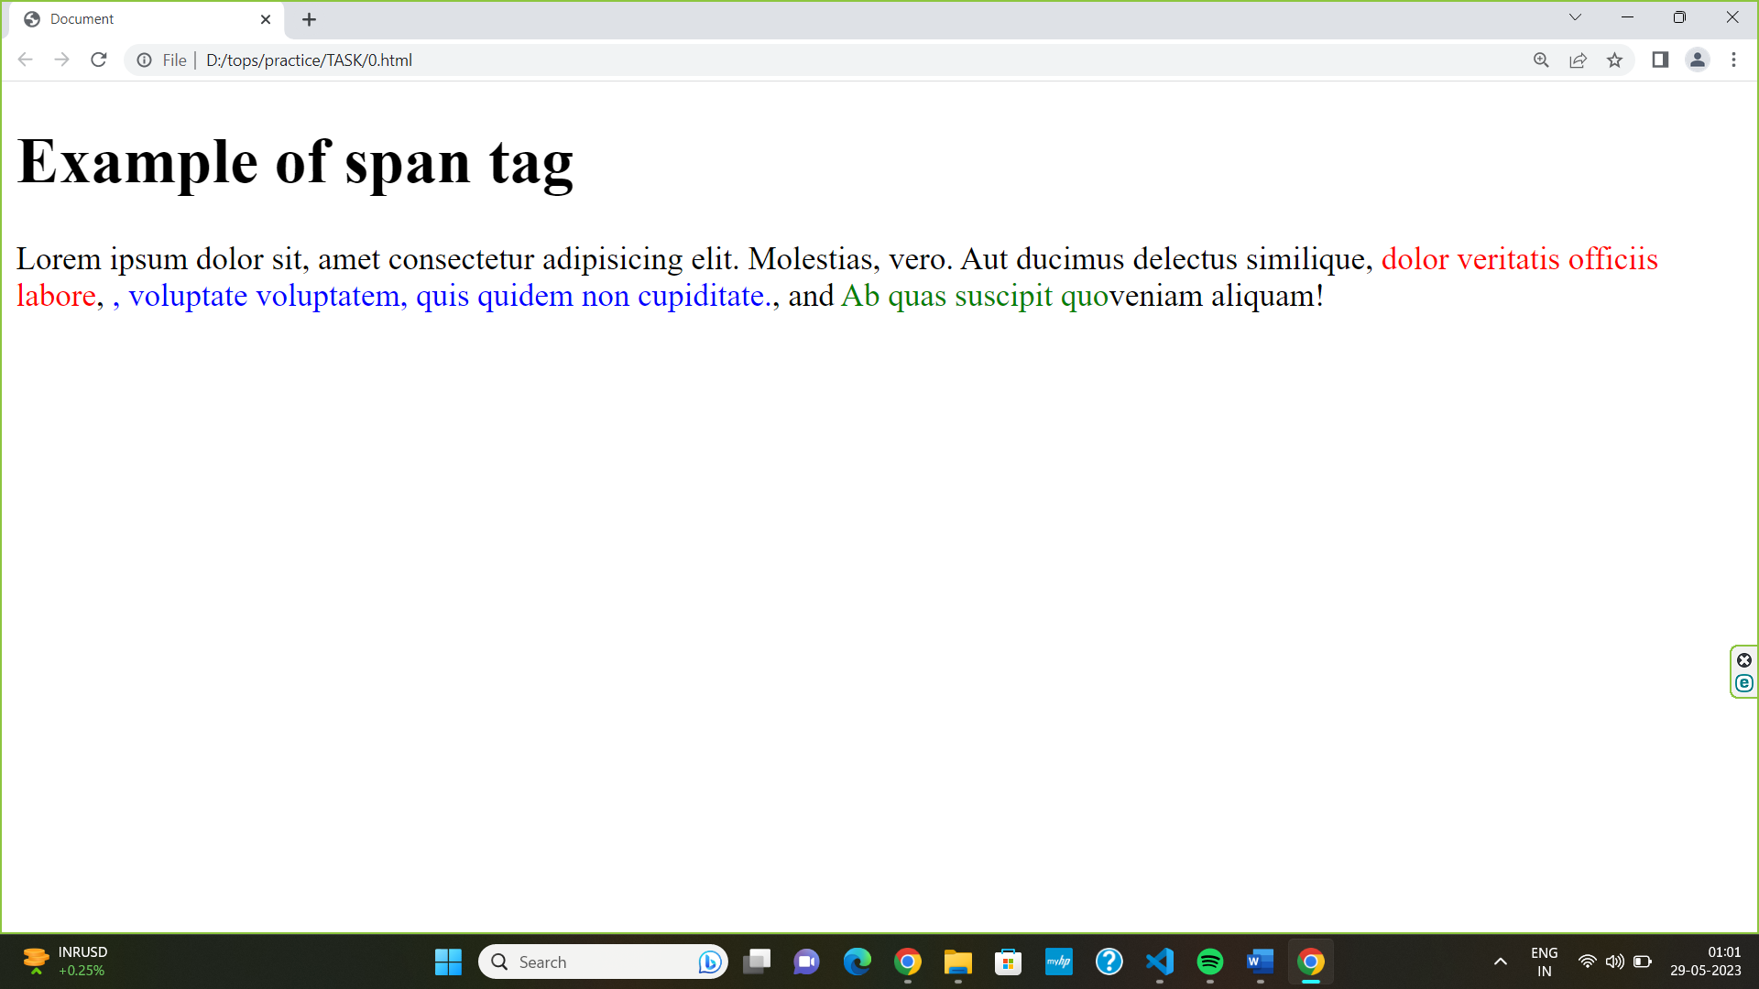

1. **How to insert a picture into a background image of a web page? With**

**Example.**

* In the body tag, specify a background image in the background attribute by passing the URL of the image or location path.
* Adding css styling properties.

Ex.:-

<body background = "URL or path" > Website Body </body>

1. **How are active links different from normal links?**

* A normal link is just a line of code that contains a pointer to another resource.
* An active link is that line of code in action, opening that other resource.
* Some browser recognize an active link when the mouse cursor is placed over that link, other recognize active link when the link has the focus.
* Those that don’t have a mouse cursor over that link are considered normal links.
* The default colour for normal and active link is blue.

Ex.:-

<style>

        a:active {

        background-color: rgb(8, 91, 140);

      }

    </style>

</head>

<body>

      </head>

      <body>

      <h1>active link</h1>

      <a href="https://www.google.com/">google</a><br>

      <a href="https://www.youtube.com/">youtube</a><br>

      <a href="https://www.cricbuzz.com/">cricbuzz</a>

      </body>

      </html>

1. **What are the different tags to separate sections of text?**

* There are several tags can be used to separate section to text.
* <p> tag: this tag is used to define a paragraph. It used to separate text into paragraphs.
* <br> tag: This tag is used to insert a line break. It is used to separate lines of text.
* <blockquote> tag: this tag is used to define a log quotation. It is used to separate quoted text from the rest of the text.
* <section> tag: this tag is used to define a section in a document. It is used to divide the content into sections and subsections.

Ex.:-

<body>

    <section>

    <p>It was a dark and stormy night</p>

    <p>

        A paragraph has three major parts- 1. Topic sentence<br> 2. Supporting sentences<br> 3. Concluding sentence

        1. Topic Sentence A topic sentence is a precise statement that reflects the main idea of the paragraph.

    </p>

    </section>

    <p>It should be carefully written as it will show the reader what you are going to talk about.</p>

</body>

Out put.:-

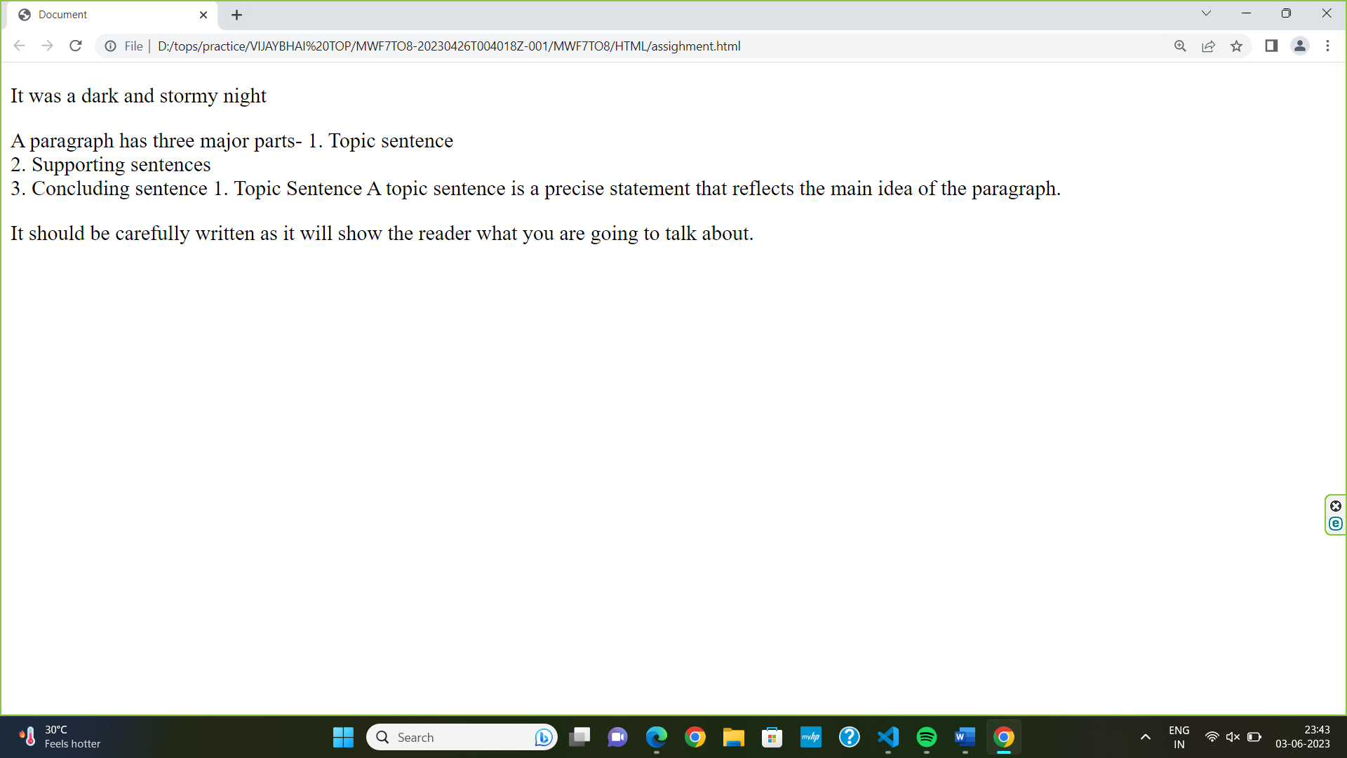

1. **What is SVG?**

* SVG stands for scalable vector graphics. It is used to display vector-based graphics over the web.
* The graphical content it can render is based on XML format. With SVG, the graphical content is of superior quality thereby providing the user with the ability to furnish high-quality images.

**Ex.:-**

<body>

        <svg width="400" height="180">

            <rect x="50" y="20" width="150" height="150" style="fill:rgb(15, 155, 173);stroke:rgb(139, 29, 47);

            stroke-width:5;fill-opacity:0.1;stroke-opacity:0.9" />

          </svg>

      </body>

**Out put:-**

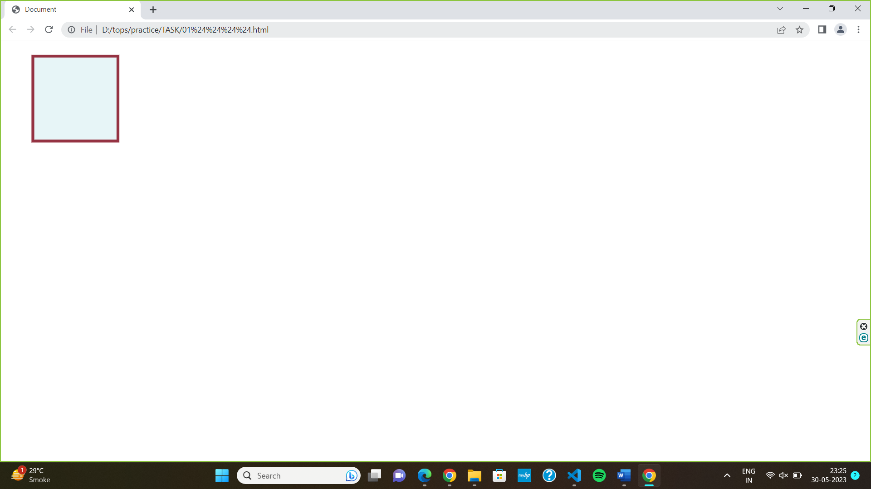

1. **What is difference between HTML and XHTML?**

* XHTML and HTML5 are two different markup languages used for creating web pages.
* XHTML is more structured and stricter than HTML5, and requires that all tags be properly closed and in lowercase.
* HTML5 is more forgiving of errors and allows for self-closing tags.
* XHTML requires a Document Type Declaration, while HTML5 does not.
* XHTML documents are validated using XML parsers, while HTML5 documents are validated using the HTML5 validator.
* HTML5 is designed to be backward-compatible with older versions of HTML, while XHTML is not.

1. **What are logical and physical tags in HTML?**

* Physical and logical tags are used in html for better visibility and

Understanding of the text by the user on the web page.

* Logical tags are used in html to display the text according to the logical styles.
* Physical tags are used in html to provide actual physical formatting to the text.

Ex.:- logical tags

<abbr> - Defines an abbreviation

<acronym> - Defines an acronym

<address> - defines an address element

<cite> - defines citation

<code> - defines computer code tex

<del> - defines text

<body>

     <h1>logical tag</h1>

     <abbr title=""> nikunj savalia</abbr> <br>

     <address>maninagr ahmedabad</address><br>

     <cite>tops</cite><br>

     <code>.in.com.net()</code><br>

     <del>this tag delet tag</del>

</body>

</html>

Physical tag:-

<b> - Defines bold text

<big> - define big text

<i> - defines italic text

<small> - defines small text

<sup> - defines superscripted text

<tt> - defines teletype text

<u> - deprecated. use styles instead

EX.:-

<body>

    <h1> Physical Tags </h1>

    <b> MAKE WORLD BEAUTIFUL </b> <br>

    <i> SAVALIA </i> <br>

    <small> NIKUNJ  </small> <br>

    X<sup>2 </sup> <br>

    <sub>X</sub>3<sub>Y</sub>3 <br>

    <u> THE RED DEVIL</u> <br>

    </body>

